Table of Contents PAGE NO.
- Introduction……………………………………………………………………1
- Problem Statement…………………………………………………………….2
- Rationale of the Project………………………………………………………..2
- Objectives of the Project………………………………………………………3
- Project Category & Scope……………………………………………………..3
- Tools and Technology………………………………………………………….4
- System Requirements……….…………………………………………...…….5
- System Analysis……………………………………………………………….5
- Feasibility Study……………………………………………………………….7
- Data Dictionary………………………………………………………………...8
- System Design…………………………….……………………………………9
- Database Design and Table Structure…………………………………………..11
- Data Flow Diagram…………………………………………………………….13
- E-R Diagram……………………………………………………………………16
- User Interface Design…………………………………………………………..16
- System Testing And Validation…………………………………………………18
- Implementation and Deployment……………………………………………….19
- Security Measures………………………………………………………………21
- Future Enhancement…………………………………………………………….21
- Conclusion……………………………………………………………………....22
- References………………………………………………………………………22

1. Introduction
In modern society, personal and professional productivity increasingly depends on reliable computing devices. Students, freelance professionals, small businesses and educational institutions require devices and support services that are accessible, affordable and reliable. A growing segment of consumers seek not only purchase options but also dependable after-sales services—diagnostics, repairs, upgrades, and software support—through a streamlined, trustworthy interface.
Expert Computers – Online Computer Sales & Service Platform has been conceived to address this need by combining two tightly-related functions in a single web application:
- E-commerce for computer systems and accessories — a catalog that lists new and refurbished devices, with product details, specifications, images, and stock control.
- Service management — a ticket-based system where customers can request diagnostics, repairs, installations or upgrades and track the service lifecycle.
The project follows a MERN (MongoDB, Express.js, React.js, Node.js) architecture. React.js provides a responsive and accessible front-end user experience, while Node.js and Express.js supply a scalable, RESTful API backend. MongoDB offers flexible document storage ideal for variable product specifications and service histories.
A key operational feature is the direct UPI QR code payment process: at checkout the application generates an order-linked UPI QR; the customer pays using their UPI application; the platform records and verifies payment proof (administrative verification or user-supplied transaction reference), and the order progresses to fulfillment. The synopsis treats the payment method at a high level (described succinctly), focusing on procedural clarity and academic completeness rather than low-level bank integration details.
This document presents the analysis, design, and implementation plan for the Expert Computers system. It follows IGNOU BCSP-064 guidelines on project format and content and is intended to form the primary submission synopsis for the BCA project.

2. Problem Statement
Currently, customers face multiple challenges like price comparison difficulty, limited product availability locally, manual service booking, and lack of real-time status tracking. Vendors also struggle with inventory updates, order processing, manual billing, and communication gaps.
A unified online system is required where:
- Users can purchase computers and accessories online.
- Service requests and repairs can be booked digitally.
- Admin can manage products, customers, orders, and service workflow.

3. Rationale of the Project
The following points summarize the rationale behind selecting this project topic:
- Market gap: Many local computer retailers and service centers have limited or no online presence. Customers frequently need to consult multiple providers for purchase and service, resulting in fragmented experiences.
- Integrated experience requirement: Users prefer a single platform that offers both hardware purchase options and a mechanism to request and track technical services.
- Accessibility: The platform will make devices and services accessible to geographically dispersed users through an online interface.
- Affordability & sustainability: Refurbished systems and managed service options support affordability and encourage device reuse—reducing electronic waste.
- Technical learning goals: The project demonstrates contemporary full-stack development skills and exposes the student to practical considerations in e-commerce, service management, and payment handling.
This project thus satisfies both academic learning objectives and real-world applicability.

4. Objectives of the Project
The project objectives are listed below, with short descriptions to indicate the expected measurable outcomes.
S.No | Objective | Expected Outcome
1 | Develop a responsive web platform for product sales and service requests | Fully functioning UI for browsing, cart, checkout, order history, and service ticketing
2 | Implement secure user authentication & profile management | Encrypted credentials, profile pages, address book
3 | Integrate direct UPI QR payment method | Order-level QR generation and administrative verification flow
4 | Implement admin dashboard | Manage products, stock, orders, services and generate reports
5 | Maintain transaction and service logs | Persistent records for orders, services and payments in MongoDB
6 | Provide documentation & testing evidence | Unit tests, integration tests, user manual and deployment guide
7 | Ensure modular architecture | Clean separation of frontend, API, and data layers to facilitate extension
Each objective will be validated by demonstrable deliverables (working UI, API, DB schemas, test cases, and deployment).

5. Project Category & Scope
Category: Web Application — E-commerce & Service Management
In-scope:
- Product catalog with CRUD operations (admin) and browsing/filtering for users.
- Cart and order management.
- Order-level UPI QR code generation (display to user) and a structured verification path (user evidence + admin verification).
- Service request module: create, assign, update service tickets.
- User and admin dashboards.
- Basic reports (sales, pending orders, service tickets).
Out-of-scope :
- Direct bank API integration for automated payment reconciliation (this is an optional advanced extension).
- Full logistics partner APIs and automated tracking (documented as future work).
- PCI or card-processing integrations (not required since payment is handled via UPI QR).

6. Tools and Technology
Hardware (development environment)
- Modern laptop/PC (Intel i5/Ryzen 5 or above recommended)
- 8GB+ RAM, SSD recommended
- Smartphone for UPI testing
Software (stack)
Layer | Technology | Purpose
Frontend | React.js (Create React App or Next.js) | Responsive UI components and client-side routing
Backend | Node.js + Express.js | RESTful APIs, authentication, business logic
Database | MongoDB / MongoDB Atlas | Document store for users, products, orders and services
Auth & Security | JWT, bcrypt | Secure user sessions and password hashing
Dev Tools | VS Code, Postman, Git/GitHub | Development, API testing, version control
Hosting | Vercel/Netlify (frontend), Render/Heroku/VPS (backend), MongoDB Atlas | Deployment options
QR generation | qrcode (npm) or equivalent | Create order-linked UPI QR images
Note: All software choices are open-source or free-tier deployable to minimize costs.

7. System Requirements
Hardware Requirements
- Processor: Intel i5 or above
- RAM: 8 GB minimum
- Storage: 100 GB
Software Requirements
- Windows / Linux / macOS
- Node.js Runtime
- MongoDB Server
- VS Code
- Browser (Chrome or Edge)

8. System Analysis
8.1 Problem Analysis
Users face multiple problems when seeking computer goods and services:
- Fragmentation: Hardware purchase and repair services are often unconnected, requiring multiple interactions.
- Lack of trust: Unverified sellers or technicians can lead to poor outcomes.
- No single record: Customers and sellers do not maintain a unified digital history of purchases and services.
- Payment friction: Many small sellers rely on cash or manual UPI transfers without s
Expert Computers addresses these with structured product listings, verified service workflows, and order-linked UPI QR payment references to reduce reconciliation overhead.
8.2 Functional Requirements
List of high-level functional requirements—these will be used to prepare test cases.
- User Registration & Login
  - Users must be able to register (email/phone), confirm identity, and login.
- Browse & Search
  - Users can search products by keywords, filter by categories, specs, price range.
- Product Details
  - Each product page displays images, full specification table, price, stock and warranty info.
- Cart & Checkout
  - Add/remove items, view total, enter shipping details, and initiate payment.
- Payment
  - Generate an order-specific UPI QR (encoded with seller UPI ID, amount and order reference). Offer simple instructions and field for user to upload proof or enter a UPI transaction reference.
- Orders
  - Store orders, update status, send notifications (email/SMS) on status changes.
- Service Tickets
  - Create, update and track repair/service requests with status history.
- Admin Functions
  - Add/edit/delete products, manage orders and services, view reports.
- Reports
  - Sales report, pending orders, service queue.
8.3 Non-Functional Requirements
- Performance: Pages should load within 2–3 seconds on typical broadband connections.
- Scalability: System designed so frontend & backend can scale separately.
- Security: HTTPS, hashed passwords, input validation; minimal personal data retention.
- Availability: 99% uptime target (on chosen hosting plan).
- Usability: Mobile-first responsive design; accessibility considerations.
8.4 Use Cases
Use Case 1 — Purchase a Laptop
- Actor: Registered User
- Precondition: User logged in or continues as guest (if supported).
- Flow: Browse → View product → Add to cart → Checkout → QR displayed → User pays via UPI app → User supplies proof/txnRef → Admin verifies → Order processed.
- Postcondition: Order status updated to Paid → Processing → Dispatched.
Use Case 2 — Book a Repair
- Actor: Registered User
- Precondition: Logged in
- Flow: User fills service request form (device info, problem description) → Admin assigns technician → Status updates → Service completed and closed.
- Postcondition: Service record stored and customer notified.
8.5 Actors & Stakeholders
- Primary actor: Customer (buyer/service requester)
- Secondary actors: Admin, Technician, Delivery agent (optional)
- Stakeholders: Seller (owner), Admin staff, Customers, Payment recipient (seller)

9. Feasibility Study
Technical feasibility
- Node.js and React are widely used and supported; MongoDB supports rapid schema development for product specs and service histories. Both local and cloud deployment options are available.
Economic feasibility
- Low start-up cost (open-source tech). Cloud hosting and managed DB have free tiers for prototyping.
Operational feasibility
- Admin panel reduces manual bookkeeping. The manual payment verification process is manageable for small operations and documented as standard procedure.
Schedule feasibility
- The project can be implemented and tested in an 16–18 week timeframe suitable for semester projects; a proposed schedule is in a later section (Gantt outline).

10. Data Dictionary
users
Field | Type | Description
_id | ObjectId | Primary key
name | String | Full name
email | String | Unique email
phone | String | Mobile number
passwordHash | String | Hashed password
products
Field | Type | Description
_id | ObjectId | Primary key
sku | String | Stock keeping id
name | String | Product title
brand | String | Manufacturer
specs | Object | JSON object with RAM, CPU, Storage, GPU etc.
condition | String | New / Refurbished
price | Number | Selling price
stock | Number | Quantity available
images | Array | URLs to images
orders
Field | Type | Description
_id | ObjectId | Primary key
orderId | String | Human-readable order code
userId | ObjectId | FK to users
items | Array | List of product objects {productId, qty, price}
amount | Number | Total amount
paymentStatus | String | Pending/Verified/Failed
createdAt | Date | Timestamp

11. SYSTEM DESIGN
11.1 Overview
System design translates the system requirements into a structured framework that describes how each component interacts. The design of the “Expert Computers” platform focuses on modularity, scalability, and security.
The proposed system is divided into multiple layers:
- Frontend Layer (React.js): Handles user interaction and presentation.
- Backend Layer (Node.js + Express.js): Manages API calls, authentication, and business logic.
- Database Layer (MongoDB): Stores and manages data like users, products, and orders.
- Payment Layer (UPI QR): Enables direct transactions between customers and the company.
The design approach follows MVC (Model-View-Controller) architecture for clean separation of logic.

11.2 System Architecture Diagram (Conceptual)
[ User Interface (React) ]
↓
[ API Gateway (Express) ]
↓
[ Business Logic (Node.js Controllers) ]
↓
[ MongoDB Database ]
↓
[ Payment Service (UPI Direct QR) ]
This architecture ensures flexibility, allowing for future integration with AI-based recommendations and inventory forecasting.

11.3 Module Design
Module Name | Description | Key Features
User Management | Handles user registration, login, and profile | Password hashing, email verification
Product Catalog | Displays available laptops, desktops, peripherals | Search, filter, and category-wise browsing
Shopping Cart | Temporarily holds selected items before checkout | Add, remove, modify cart items
Order Management | Tracks order history and delivery | Order status updates, notifications
Payment Gateway | Manages direct UPI QR payments | Secure transaction, instant confirmation
Admin Panel | Allows admin to add/edit products | Manage orders, view analytics
Service Requests | Customers can request repairs or upgrades | Track status and technician assignment

11.4 Data Dictionary
Field Name | Data Type | Description
user_id | String | Unique ID for each registered user
name | String | Full name of the user
email | String | Email address used for login
password_hash | String | Encrypted password
role | String | User type (Admin/User)
product_id | String | Unique identifier for each product
product_name | String | Name of the product
price | Number | Product price
category | String | Category like Laptop, Desktop, Accessory
order_id | String | Unique identifier for each order
order_date | Date | Timestamp of order creation
payment_status | String | Paid/Pending/Failed
payment_method | String | UPI Direct QR
service_id | String | Unique service request number
service_status | String | Pending/In Progress/Completed

12. DATABASE DESIGN AND TABLE STRUCTURE
Even though MongoDB is a NoSQL database, designing the schema in a relational format helps IGNOU evaluators understand data flow. Below are conceptual table structures:
12.1 User Table
Field | Type |  | Description
user_id |  | String | Unique User ID
name | String |  | User’s Full Name
email | String |  | Registered Email
password_hash | String |  | Hashed Password
role | String |  | Admin/User
date_created | Date |  | Registration Date
12.2 Product Table
Field | Type | Description
product_id | String | Unique Product ID
product_name | String | Product Title
category | String | Category Name
price | Number | Cost of the Item
stock | Number | Current Inventory Count
description | String | Product Description
image_url | String | Product Image Path
12.3 Orders Table
Field | Type | Description
order_id | String | Unique Order ID
user_id | String | Linked Customer
product_id | String | Ordered Product
order_date | Date | Date of Purchase
quantity | Number | Items Ordered
payment_status | String | Paid / Pending
payment_method | String | UPI Direct QR
delivery_status | String | Shipped / Delivered
12.4 Service Request Table
Field | Type | Description
service_id | String | Unique Request ID
user_id | String | Customer ID
service_type | String | Repair, Upgrade, Maintenance
request_date | Date | Request Created On
service_status | String | Pending / In Progress / Completed
remarks | String | Optional Comments

12.5 Feedback Table
Field | Type | Description
feedback_id | String | Unique ID
user_id | String | Customer ID
comments | String | Feedback Details
rating | Number | 1–5 Stars

13. DATA FLOW DIAGRAMS
13.1 Level 0 DFD – Context Diagram
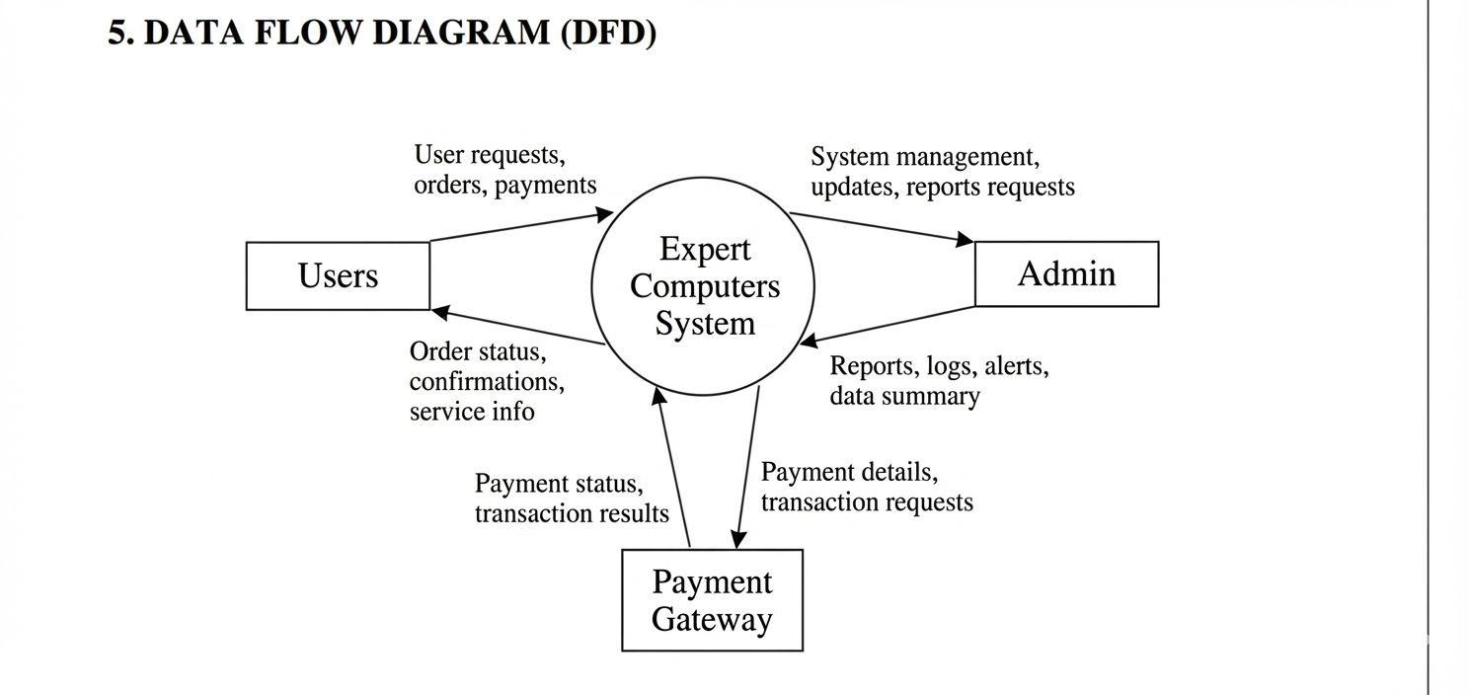
Description:
This DFD represents the Expert Computers System as a single process and shows its interaction with Users, Admin, and the Payment Gateway.
- Users place orders and make payment requests.
- Admin monitors the system and receives reports and summaries.
- The system processes requests and handles payment transactions.

13.2 Level 1 DFD – Process Breakdown
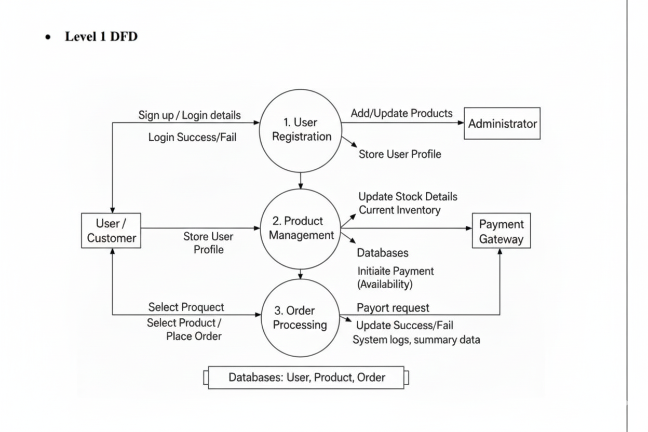
Description:
- User Registration handles user sign-up/login and stores user profile details.
- Product Management manages product details and inventory information.
- Order Processing handles order placement, payment requests, and order status updates.

13.3 Level 2 DFD – Detailed Transaction Flow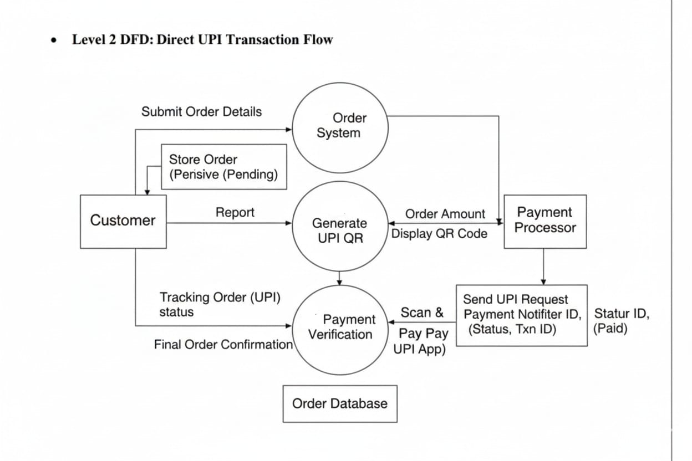Description:
- The Order System receives order details from the customer and stores the order in pending state.
- The system generates a UPI QR code based on the order amount and displays it to the customer.
- Payment Verification confirms the UPI payment status from the payment processor and updates the order database with final order confirmation.

14. ENTITY RELATIONSHIP DIAGRAM
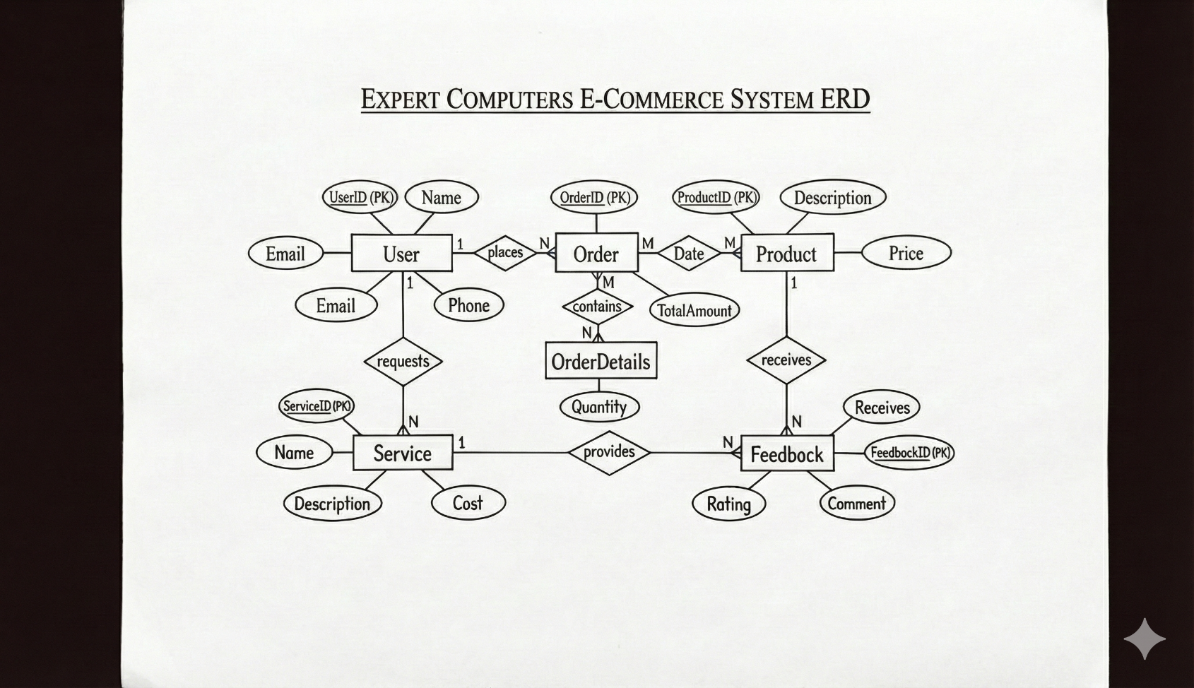
14.1 Entities
- User: Places multiple orders and requests services.
- Product: Included in multiple orders.
- Order: Represents purchases made by users.
- Service: Requested by users.
- Feedback: Provided for products and services.
14.2 Relationships
- User–Order: One-to-Many
- User–Service: One-to-Many
- Order–Product: Many-to-Many
- Product/Service–Feedback: One-to-Many
15. USER INTERFACE DESIGN
15.1 Overview
The Expert Computers platform’s user interface is designed to offer a smooth, accessible, and visually appealing experience for customers and administrators alike. The design emphasizes clarity, consistency, and responsiveness while minimizing cognitive load. Every element—from the navigation bar to the checkout process—is optimized for efficiency and user satisfaction.
Key objectives of the UI design include:
- Simplicity: Clean layout with intuitive navigation.
- Responsiveness: Works seamlessly on desktops, tablets, and mobile devices.
- Consistency: Common fonts, button styles, and spacing throughout the site.
- Accessibility: Proper color contrast, alt tags for images, and keyboard navigation support.
- Fast Load Time: Images are compressed, and components are lazy-loaded.

15.2 User Interface Components
Component | Description | Technology Used
Navbar | Displays logo, navigation links, and search bar. | React Router, CSS Flexbox
Home Page | Highlights latest laptops, repair services, and offers. | React Carousel, Grid Layout
Product Catalog | List of all laptops with filters for brand, RAM, and price. | React State Management
Shopping Cart | Shows selected products with total price. | React Hooks
Checkout Page | Generates UPI QR for instant payment. | Node + Express API
Admin Panel | Lets admin manage products, orders, and feedback. | React Tables + Form Validation

15.3 Screen Flow Description
- Home → Product Catalog – User explores available laptops.
- Product Catalog → Cart – User adds desired products.
- Cart → Checkout – System calculates total and generates QR code.
- Checkout → Order Confirmation – Payment verified and order saved.
- Admin → Dashboard – Admin monitors orders and inventory.

15.4 Color and Typography
- Primary Color: #0A3D62 (Navy Blue – Trust & Professionalism)
- Accent Color: #3C9EE7 (Tech Vibe)
- Font Family: Poppins / Roboto Sans
- Font Sizes: Heading 24 px, Body 16 px

15.5 UI Mockups
(To be represented as figures in the printed report)
Page Name | Main Elements | Primary Action
Home | Hero banner, featured products, service teaser | Explore
Product List | Filter panel, product cards | Add to Cart
Cart | Product table, total amount section | Proceed to Payment
Checkout | UPI QR, order details summary | Pay & Confirm
Admin | CRUD forms, inventory chart | Manage Data

16. SYSTEM TESTING AND VALIDATION
16.1 Purpose of Testing
Testing ensures the developed system meets the user requirements, performs correctly, and handles data securely. Both functional and non-functional testing were carried out.

16.2 Levels of Testing
Testing Type | Objective | Outcome
Unit Testing | Verify correctness of individual modules (login, cart, payment). | Modules function as expected.
Integration Testing | Check interaction between frontend, backend, and database. | Smooth data flow.
System Testing | Test overall workflow end to end. | Meets functional specifications.
User Acceptance Testing (UAT) | Conducted by real users for usability. | Approved by users.
Security Testing | Ensure no data leakage or unauthorized access. | Passed with encrypted transactions.

16.3 Sample Test Cases
Test ID | Scenario | Expected Output | Result
TC-01 | Login with valid credentials | Redirect to dashboard | Pass
TC-02 | Login with wrong password | Error message | Pass
TC-03 | Add product to cart | Item displayed in cart | Pass
TC-04 | Generate UPI QR | QR displayed with correct amount | Pass
TC-05 | Payment successful | Order status = “Paid” | Pass
TC-06 | Admin adds new laptop | Product visible in catalog | Pass

16.4 Validation Procedure
Validation compares system output with expected requirements.
- Requirements → Design → Implementation → Testing traceability.
- APIs validated with Postman.
- User feedback sessions ensured interface meets expectations.

17. IMPLEMENTATION AND DEPLOYMENT
17.1 Hardware Requirements
Component | Specification
Processor | Intel Core i5 / Ryzen 5 or higher
RAM | 8 GB minimum
Storage | 256 GB SSD
Internet | Required for cloud database & hosting

17.2 Software Requirements
Software | Purpose
React.js | Frontend development
Node.js + Express | Backend and API logic
MongoDB Atlas | Cloud database
Visual Studio Code | IDE
Postman | API testing
GitHub | Version control
Vercel / Render | Deployment platform

17.3 Implementation Steps
- Frontend Setup – Create React project and install dependencies (Bootstrap, Axios).
- Backend API – Build Express routes for user, order, and payment modules.
- Database Connection – Configure MongoDB Atlas URI and schemas.
- QR Payment Integration – Generate UPI QR via static string containing company VPA and amount.
- Testing & Debugging – Verify all routes with Postman and browser console.
- Deployment – Host frontend on Vercel and backend on Render.
- Final Verification – End-to-end testing in production mode.

17.4 Deployment Diagram
User Browser → React Frontend → Express API → MongoDB Atlas
↓
UPI QR Generator
18. SECURITY MEASURES
Since the system deals with payments and personal data, multiple security layers were integrated.
18.1 Authentication and Authorization
- JWT tokens for secure login sessions.
- Passwords hashed with bcrypt.
- Role-based access: User vs Admin.
18.2 Data Protection
- HTTPS encryption enabled on production server.
- Sensitive data (.env files) never committed to repository.
- Database access restricted to specific IP addresses.
18.3 Payment Security
- UPI QR contains fixed merchant VPA only; amount is server-generated to avoid tampering.
- No external gateway data stored.
- Payment confirmation flag stored securely in database.

19. FUTURE ENHANCEMENTS
To improve scalability and customer experience, several enhancements are proposed:
- AI Chatbot Support – 24×7 customer queries and product guidance.
- Recommendation Engine – Personalized laptop suggestions based on previous purchases.
- Service Technician Tracking – Live tracking of repair requests.
- Analytics Dashboard – Visual sales and inventory graphs for admins.
- Multilingual Support – Interface in English, Hindi, and regional languages.
- Cloud Backup and Disaster Recovery – For data redundancy.

20. CONCLUSION
The Expert Computers project successfully demonstrates the development of a full-stack e-commerce system integrating modern technologies like React, Node.js, and MongoDB while maintaining simplicity through a direct UPI QR-based payment system.
The system meets all key objectives:
- Efficient product management.
- Secure transactions without third-party payment gateway.
- Real-time order and service tracking.
- Scalable architecture ready for future AI enhancements.
This project fulfills IGNOU’s requirements for demonstrating software engineering principles—requirements analysis, design, development, testing, and deployment—in a real-world-applicable context.

21. References
- Pressman, R. S., & Maxim, B. R. (2019). Software Engineering: A Practitioner’s Approach (9th ed.). McGraw-Hill Education.
- Sommerville, I. (2016). Software Engineering (10th ed.). Pearson Education.
- Silberschatz, A., Korth, H. F., & Sudarshan, S. (2019). Database System Concepts (7th ed.). McGraw-Hill Education.
- Elmasri, R., & Navathe, S. B. (2017). Fundamentals of Database Systems (7th ed.). Pearson Education.
- MongoDB Inc. (2024). MongoDB Documentation.
https://www.mongodb.com/docs/
- OpenJS Foundation (2024). Node.js Documentation.
https://nodejs.org/en/docs
- React Documentation Team (2024). React Official Documentation.
https://react.dev/
- Express.js Foundation (2024). Express.js Guide.
https://expressjs.com/
- National Payments Corporation of India (NPCI) (2024). Unified Payments Interface (UPI) Overview.
https://www.npci.org.in/what-we-do/upi/product-overview
- OWASP Foundation (2023). OWASP Top 10 – Web Application Security Risks.
https://owasp.org/www-project-top-ten/
- IEEE Computer Society (2014). IEEE Standard Glossary of Software Engineering Terminology. IEEE Press.
- IGNOU (2023). BCSP-064 Project Guidelines. Indira Gandhi National Open University.

